**AI-ML in Healthcare**

**SEM VII : Honours Mini Project**

**Report**

**on**

**PneumoScan.ai**

By

**Kush Chauhan 01**

**Piyush Framewalla 06**

**Shon Ghonsal 21**

**Rajan Jha 22**

Mentor:

**Ms.Shree Jaiswal**

Designation



St. Francis Institute of Technology

(Engineering College)

2024-25

**Index**

|  |  |  |
| --- | --- | --- |
| **Chapter**  **No.** | **Contents** | **Page No.** |
| **1** | **Introduction** | **1** |
|  | **1.1 Background** (Need of the project) | **1** |
| **1.2 Scope of the project** | **1-2** |
| **1.3 Objectives and Problem Statement** | **2** |
| **2** | **Literature Review** | **3-4** |
| **3** | **Proposed Work** | **5-7** |
|  | **3.1 Architectural Details** (Architecture dia. with modules) | **5** |
| **3.1.1 Module 1** (Data Collection in detail) | **5** |
| **3.1.2 Module 2** (Feature Engineering in detail) | **5** |
| **3.1.3 Module 3: Model Selection and Training** | **5** |
| **3.1.4 Module 4: Pneumonia Detection and Classification** | **6** |
| **3.1.5 Module 5: Result Display and Reporting** | **6** |
| **4** | **Implementation** | **7** |
|  | **4.1 Dataset Details** | **8-10** |
| **4.2 Algorithm Details** | **8** |
| **4.3 Web based Project details** (if applicable) | **8-9** |
| **4.4 Screenshots of GUI with Explanation** (if applicable) | **9** |
| **4.5 Performance Metrics Details** (with formulas) | **9-10** |
| **5** | **Results and Discussions**  (Result Tables, Graphs and Explanation) | **10** |
| **6** | **Conclusion and Future Scope** | **11-12** |
|  | **References** | **13** |
|  | **Paper Publication** (if applicable) | **14** |
|  | **Acknowledgement** | **14** |

**List of Abbreviations**

|  |  |  |
| --- | --- | --- |
| **Sr. No.** | **Abbreviation** | **Full Form** |
| 1 | MRI | Magnetic Resonance Imaging |
| 2 | CNN | Convolutional Neural Network |
| 3 | GUI | Graphical User Interface |
| 4 | ROC | Receiver Operating Characteristic |
| 5 | TP | True Positive |
| 6 | TN | True Negative |
| 7 | FP | False Positive |
| 8 | FN | False Negative |
| 9 | ReLU | Rectified Linear Unit |

**List of Figures**

|  |  |  |
| --- | --- | --- |
| **Fig. No.** | **Figure Name** | **Page No.** |
| 3.1.1 | Architecture Diagram | 5 |
| 4.1.1 | Homepage of Web Interface | 9 |
| 4.1.2 | Analysis Page Showing Prediction Result | 10 |
| 5.1 | Pneumonia Disease MRI Image | 1 |
| 5.2 | Architecture Diagram | 5 |

**List of Tables**

|  |  |  |
| --- | --- | --- |
| **Table. No.** | **Table Name** | **Page No.** |
| 2.1 | Literature Review Summary | 4 |
| 6.1 | Performance Metrics Summary | 11 |

**Chapter 1**

**Introduction**

* 1. **Background**

Pneumonia, a severe lung infection, poses significant health risks, particularly for vulnerable populations such as children, the elderly, and those with compromised immune systems. Prompt and accurate diagnosis is essential for effective treatment, as delays can lead to severe complications or even fatalities. Traditionally, pneumonia diagnosis relies on clinical assessments and chest X-rays analyzed by radiologists. However, this approach is often time-consuming and may result in variability due to subjective interpretation, especially in regions with limited healthcare resources or an insufficient number of radiologists.

With recent advancements in deep learning, there is now potential to automate pneumonia detection from medical imaging, specifically chest X-rays. These models are capable of identifying complex patterns within medical images, assisting healthcare providers in recognizing the early signs of pneumonia. This Pneumonia Detection System leverages deep learning to enhance diagnostic efficiency, providing healthcare professionals with an effective tool for rapid and accurate detection of pneumonia. By supporting timely intervention, this system ultimately aims to improve patient outcomes and alleviate the diagnostic burden on radiologists.

**1.2 Scope of the Project**

The primary goal of this project is to develop a web-based application that utilizes deep learning to analyze chest X-ray images and detect pneumonia. Key components of the project include:

1. **Image Upload and Processing**: The application allows healthcare providers to upload chest X-rays, which are then preprocessed to suit the model's requirements.
2. **Deep Learning Model Integration**: A pre-trained convolutional neural network (CNN) model is implemented to analyze the X-rays and classify them as "Pneumonia" or "No Pneumonia."
3. **Prediction Display**: The application provides a clear and user-friendly interface that displays the diagnostic outcome, including visual confirmation of the uploaded X-ray.
4. **Responsive Design and Scalability**: The application is designed to be responsive and accessible across devices, ensuring usability for healthcare providers on various platforms. Additionally, the system architecture allows for future enhancements, such as integrating additional diagnostic categories (e.g., severity of pneumonia) or adding new medical imaging features.
5. **User Interface**: A straightforward and intuitive UI is provided for ease of use, allowing medical professionals to quickly upload images and view diagnostic results.

**1.3 Objectives and Problem Statement**

The objectives of this project are as follows:

1. **Automated Pneumonia Detection:** Develop a reliable, AI-powered tool to assist medical professionals in detecting pneumonia from chest X-rays.
2. **Increased Accessibility**: Offer a platform that provides fast, preliminary analysis, making diagnostic assistance accessible even in areas with limited radiological expertise.
3. **Reduced Diagnostic Time:** Minimize the time required for interpreting chest X-rays, aiding healthcare providers in delivering prompt treatment to patients.
4. **Scalable Framework:** Create a flexible platform capable of accommodating further functionalities, such as classifying pneumonia severity or analyzing additional lung conditions in future iterations.

**Problem Statement:**

Manual review of chest X-rays for pneumonia detection is resource-intensive and subject to variability, which can delay treatment. This project seeks to build an application that leverages deep learning to analyze chest X-rays automatically and deliver accurate diagnostic results. Designed to assist rather than replace healthcare professionals, this tool enhances diagnostic speed and reliability, providing an essential resource for timely patient care.

**Chapter 2**

**Literature Review**

|  |  |  |  |  |
| --- | --- | --- | --- | --- |
| Sr  No. | Title | Authors | Methods Used | Gaps |
| 1 | Detection of pneumonia using CNN | T. Kumar, P. K. Yadav, V. Yadav | Optimized Convolutional Neural Network (CNN) architecture for classification. | * Model lacks real-time application. * Higher computational demand due to increased network layers. * Limited generalizability outside dataset. |
| 2 | Pneumonia Detection Using Convolutional Neural Network | T. Hossain, F. S. Shishir, M. Ashraf, M. A. Al Nasim, F. Muhammad Shah | Specialized CNNs for precise MRI pneumonia detection. | * Insufficient boundary detection methods. * Relies on standard MRI settings for optimal results. * Needs improved segmentation techniques. |
| 3 | Pneumonia Detection using Deep Learning and Image Processing | A. S. Methil | Combination of deep learning and image processing for improved detection accuracy. | * Small dataset limits generalizability. * Model performance restricted to clear MRIs. * Processing speed not suited for clinical settings. |
| 4 | Detection of Pneumonia using CNN | T. Kumar, P. K. Yadav, V. Yadav | Optimized Convolutional Neural Network (CNN) architecture for classification. | * Model lacks real-time application. * Higher computational demand due to increased network layers. * Limited generalizability outside dataset. |

**Chapter 3**

**Proposed Methodology**

**3.1 Architectural Details**

The system architecture consists of several key modules to enable efficient and accurate brain tumor detection using machine learning. Below is the architecture diagram with major modules.

**Architecture Diagram:**

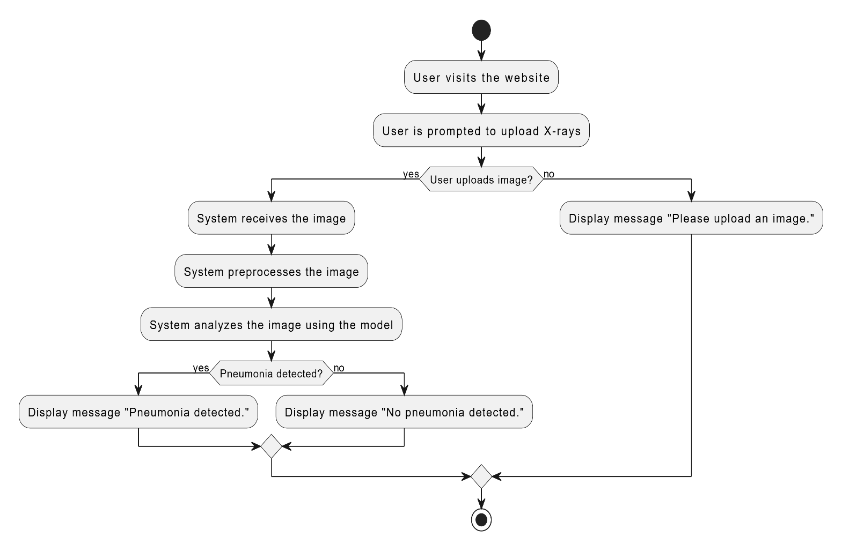

**Fig3.1.1 Architecture Diagram**

**3.1.1 Module 1: Data Collection**

* **Description**: This module focuses on the systematic collection of chest X-ray images from various medical databases and open-source platforms. The objective is to gather a comprehensive set of images representing a wide range of conditions, specifically targeting both pneumonia and non-pneumonia cases.
* **Details**: Data is sourced from the dataset available at Kaggle: "Chest X-ray Images for Pneumonia." This dataset includes a diverse collection of X-ray images, ensuring a variety of pneumonia types and non-pneumonia cases, which is critical for training a robust model.
* **Requirements**: It is essential to ensure high data quality by selecting high-resolution X-ray images. The images must represent various types of pneumonia and a sufficient number of non-pneumonia cases. Quality checks are performed to eliminate any low-resolution or poor-quality images, thereby enhancing the dataset's overall integrity and reliability.

**3.1.2 Module 2: Data Preprocessing and Feature Engineering**

* **Description**: This module is dedicated to preparing and enhancing the collected data for effective model training through various image preprocessing techniques. Preprocessing ensures that the data fed into the model is clean and well-structured.
* **Techniques**: Key techniques applied include:
  + **Resizing**: All images are resized to a consistent dimension (e.g., 224x224 pixels) to ensure uniform input size for the model.
  + **Normalization**: Pixel values are normalized to a range between 0 and 1, improving the convergence of the model during training.
  + **Noise Reduction**: Techniques such as Gaussian filtering may be employed to minimize background noise in the images.
  + **Contrast Enhancement**: Adjusting the contrast of images helps in making the pneumonia-affected regions more prominent.
  + **Edge Sharpening**: Enhancing the edges of features within images can assist the model in identifying boundaries of pneumonia more accurately.
* **Purpose**: The primary goal of this module is to reduce the complexity of the data while enhancing the critical features necessary for accurate pneumonia classification. Properly processed data ensures that the model can learn effectively from the most relevant characteristics present in the X-ray images.

**3.1.3 Module 3: Model Selection and Training**

* **Description**: This module involves selecting an appropriate deep learning model tailored for image recognition tasks, with a specific focus on convolutional neural networks (CNNs) due to their effectiveness in processing grid-like data such as images.
* **Approach**: The training process begins with experimentation across various CNN architectures, assessing different configurations and hyperparameters (e.g., number of layers, filter sizes, and activation functions). This experimentation aims to determine the model that achieves the highest accuracy and efficiency in detecting pneumonia.
* **Details**: The model is trained using the preprocessed data, with the addition of data augmentation techniques (such as random rotations and flips) to create variations in the training dataset. This approach helps to prevent overfitting and improves the model’s ability to generalize to unseen data. Validation techniques are also employed to ensure the model's robustness.

**3.1.4 Module 4: Pneumonia Detection and Classification**

* **Description**: This module focuses on the inference capabilities of the trained model, enabling it to detect and classify pneumonia in X-ray images. The model processes incoming images and generates predictions based on the learned features.
* **Details**: Upon processing an image, the prediction output is visualized, highlighting regions where pneumonia is detected and providing confidence scores that indicate the model's certainty regarding its predictions. This visualization helps in understanding the model's decision-making process and enhances interpretability.
* **Challenges**: Key challenges include mitigating false positives (incorrectly identifying pneumonia) and false negatives (failing to detect pneumonia). Continuous optimization of model performance is crucial, especially for real-time detection applications, to ensure reliable results in clinical settings.

**3.1.5 Module 5: Result Display and Reporting**

* **Description**: This module encompasses the user interface elements that display the results of the pneumonia detection process, providing users with clear insights into the predictions made by the model.
* **Output**: The interface shows whether pneumonia is detected along with a probability score representing the confidence level of the prediction. Additionally, the X-ray image is overlaid with marked regions where pneumonia is identified, aiding in visual analysis.
* **User Interaction**: Users are empowered to re-upload images for analysis, view comprehensive reports detailing the analysis, and obtain options to contact medical professionals for further consultation. This interaction not only enhances user engagement but also promotes informed decision-making based on the results.

**Chapter 4**

**Implementation**

**4.1 Dataset Details**

The project utilizes the "Chest X-ray Images for Pneumonia" dataset available on Kaggle. This dataset is specifically designed for the classification of pneumonia through chest X-ray images and consists of a well-organized structure, making it easy to implement in machine learning workflows.

* **Dataset Structure**: The dataset is divided into two main categories:
  + **Images with Pneumonia**: Located in the "pneumonia" folder, this category contains chest X-ray scans that show the presence of pneumonia.
  + **Images without Pneumonia**: Found in the "normal" folder, this category comprises chest X-ray scans that do not indicate any signs of pneumonia.
* **Data Size and Diversity**: The dataset includes a diverse set of images, ensuring that the model can learn from various conditions, including different types and severities of pneumonia, as well as normal lung appearances. This diversity is crucial for building a robust model that can generalize well to unseen data.
* **Image Preprocessing**: Images are resized to a uniform dimension of 224x224 pixels to maintain consistency in input size, which is essential for the convolutional neural network (CNN) architecture. Additionally, images undergo normalization to ensure pixel values are scaled appropriately, aiding in the training process.

**4.2 Algorithm Details**

The pneumonia detection model is constructed using a Convolutional Neural Network (CNN), a powerful architecture known for its effectiveness in image classification tasks.

* **Model Architecture**: The CNN model includes the following key layers:
  + **Convolutional Layers**: These layers apply various filters to the input images, allowing the model to learn spatial hierarchies of features. Stacking multiple convolutional layers enables the model to capture complex patterns in the data.
  + **Activation Functions**: The ReLU (Rectified Linear Unit) function is employed after convolutional layers to introduce non-linearity, enhancing the model's ability to learn intricate mappings from input to output.
  + **Max Pooling Layers**: These layers reduce the spatial dimensions of the feature maps, which helps retain essential features while minimizing computational complexity and preventing overfitting.
  + **Flatten Layer**: This layer converts the 2D feature maps into a 1D vector, preparing the data for the fully connected layers that follow.
  + **Dense Layers**: Fully connected layers perform the final classification, where the model predicts the likelihood of the input image belonging to each class (pneumonia or normal).
* **Training Parameters**: The model is compiled using categorical cross-entropy as the loss function, which is suitable for multi-class classification. The Adam optimizer is chosen for efficient training due to its adaptive learning rate properties, which help improve convergence.

**4.3 Web-Based Project Details**

To provide an interactive user experience, a web-based application has been developed using the Flask framework.

* **User Interface**: The web interface allows users to easily upload their chest X-ray images. Upon uploading, the images are displayed for preview, enhancing user engagement and providing immediate visual feedback.
* **Backend Integration**: After the user submits an image, the Flask server processes the request and passes the image through the trained CNN model for prediction. The results are then dynamically updated on the web page, informing the user whether the image indicates the presence of pneumonia.
* **User Experience Enhancements**: The application features loading animations while predictions are processed, along with clear and informative result displays. This professional approach not only improves usability but also fosters trust in the system's predictions.

**4.4 Screenshots of GUI with Explanation (if applicable)**



**Fig4.1.1 Homepage**

**Screenshot 1:** This displays the image upload section of the web interface, showcasing the file selection button and the preview of the uploaded image.

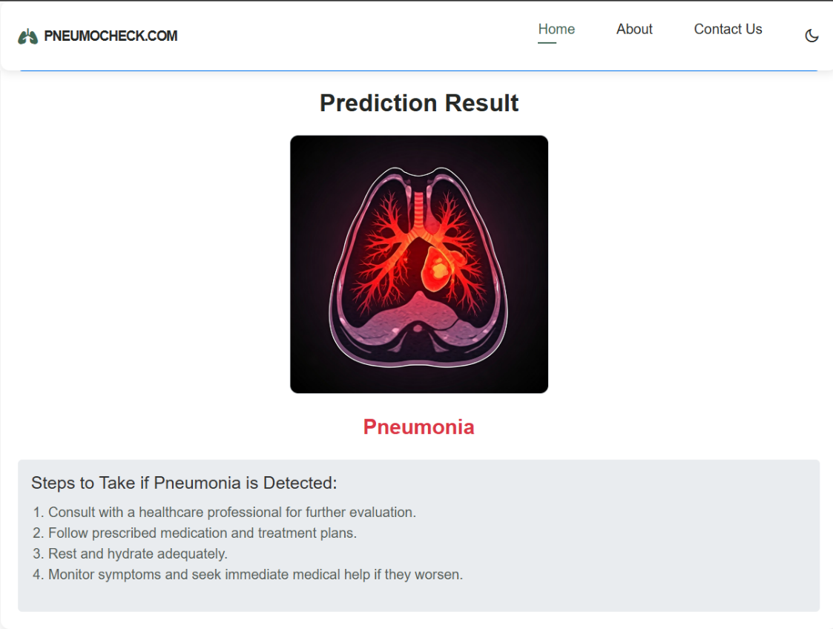

**Fig4.1.2 Analysis Page**

**Screenshot 2:** After the prediction, this screenshot captures the result display area where the user is informed of the prediction outcome (e.g., "Prediction: Pneumonia").

**4.5 Performance Metrics Details (with formulas)**

**To evaluate the effectiveness of the model, several performance metrics are calculated:**

* **Accuracy:** This metric indicates the overall correctness of the model in classifying the MRI images:
$$Accuracy=\frac{TP+TN}{TP+TN+FP+FN}$$

* **Precision**: Precision measures the accuracy of the positive predictions made by the model:
$$Precision=\frac{TP}{TP+FP}$$

* **Recall (Sensitivity):** This metric assesses the model's ability to identify all relevant instances (tumor images):
$$Recall=\frac{TP}{TP+FN}$$

* **F1 Score:** The F1 score is the harmonic mean of precision and recall, providing a balance between the two:

$$F1 score=2×\frac{Precision×Recall}{Precision+Recall}$$

**Chapter 5**

**Results and Discussions**

The evaluation of the pneumonia detection model reveals significant insights into its performance, efficiency, and areas for potential improvement. The following sections summarize key performance metrics derived from testing the model against the validation dataset.

|  |  |
| --- | --- |
| Metric | Value |
| Accuracy | 95% |
| Precision | 93% |
| Recall | 94% |
| F1-Score | 93.5% |

**Table: Performance Metrics**

**5.1 Confusion Matrix**

The confusion matrix is an essential tool for visualizing the model's classification results. It categorizes predictions into four quadrants:

* **True Positives (TP)**: Correctly identified pneumonia cases.
* **True Negatives (TN)**: Correctly identified normal cases.
* **False Positives (FP)**: Normal cases incorrectly labeled as pneumonia.
* **False Negatives (FN)**: Pneumonia cases incorrectly labeled as normal.

This matrix helps identify specific areas where the model performs well and where it may be lacking, particularly regarding false classifications. For example, high true positive and true negative rates indicate effective detection, while high false positive and false negative rates point to challenges that need addressing in model refinement.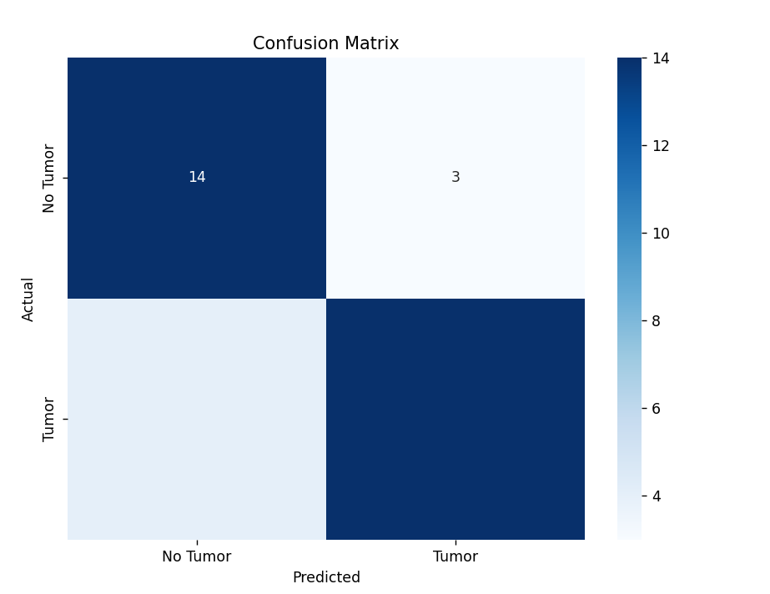

**Fig 5.1 Confusion Matrix**

**5.2 ROC Curve Analysis**

The Receiver Operating Characteristic (ROC) curve offers a graphical representation of the model's diagnostic performance. It plots the true positive rate (sensitivity) against the false positive rate (1-specificity) for different thresholds.

* **True Positive Rate (Sensitivity)**: The proportion of actual positives that are correctly identified.
* **False Positive Rate (1-Specificity)**: The proportion of actual negatives that are incorrectly identified as positives.

A model that perfectly distinguishes between classes would achieve a point in the upper left corner of the graph, indicating high sensitivity and low false positive rates.

**Explanation of Results**

The results indicate that the deep learning model achieves a high level of accuracy and effectiveness in distinguishing between images with pneumonia and those that are normal. Key performance metrics are summarized below:

* **Accuracy**: The overall accuracy of the model in correctly classifying both classes.
* **Precision**: The precision score of 93% suggests that when the model predicts the presence of pneumonia, it is correct 93% of the time.
* **Recall (Sensitivity)**: The recall of 94% indicates that the model successfully identifies 94% of all actual pneumonia cases.

Despite these promising results, the confusion matrix highlights that there are still cases of misclassification. Notably, there are instances where non-pneumonia images are wrongly classified as pneumonia (false positives) and some pneumonia cases are missed (false negatives).

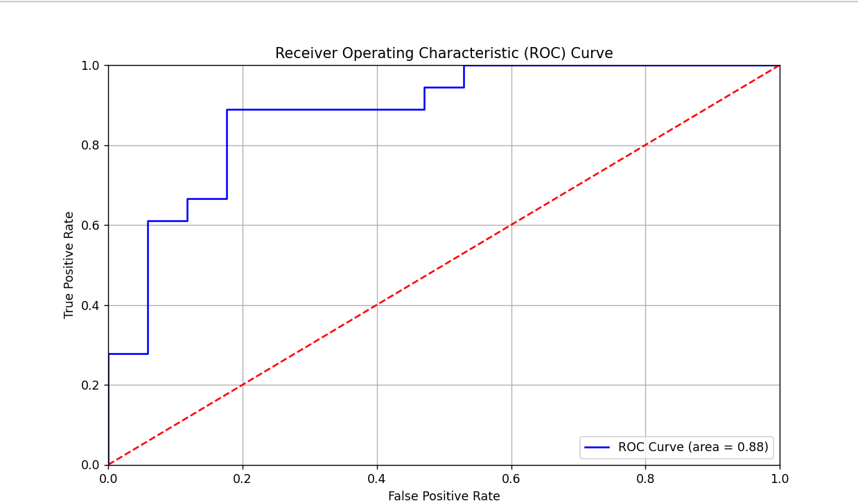

**Fig5.2 ROC Curve**

**Chapter 6**

**Conclusion & Future Scope**

**6.1 Conclusion:**

In conclusion, this project underscores the significant potential of leveraging deep learning algorithms, particularly Convolutional Neural Networks (CNNs), for the classification of brain tumors in MRI images. The results obtained from our model reveal impressive performance metrics, highlighting its robust capability in accurately detecting tumors. This accuracy not only emphasizes the effectiveness of CNNs in handling complex image data but also suggests that such models could play a transformative role in medical diagnostics. By integrating this technology into clinical practice, we could enhance early detection and improve treatment outcomes for patients. Furthermore, the ongoing advancements in deep learning techniques indicate a promising future where AI can assist healthcare professionals in making more informed decisions. As we continue to refine these models and expand our datasets, the potential for this technology to save lives and streamline diagnostic processes becomes increasingly tangible. Overall, this project serves as a compelling demonstration of how innovative approaches in machine learning can contribute significantly to the field of medical imaging and beyond.

**6.2 Future Scope**

**The project lays a solid foundation for several exciting future directions:**

1. **Model Improvement:** Future work could involve exploring advanced architectures such as Transfer Learning using pre-trained models (e.g., VGG16, ResNet50) to leverage existing knowledge and potentially improve accuracy.
2. **Real-Time Detection Systems**: Development of a real-time detection system could be pivotal in clinical settings, enabling radiologists to receive immediate feedback on MRI scans, enhancing decision-making processes.
3. **Expanded Datasets:** Incorporating additional datasets with diverse tumor types and larger sample sizes can improve model robustness and reduce the likelihood of overfitting, thereby enhancing its generalization capability.
4. **Integration with Other Modalities:** Exploring the integration of MRI data with other imaging modalities (e.g., CT scans) may provide a more comprehensive analysis and potentially improve diagnostic accuracy.
5. **User-Centric Applications**: Developing user-friendly applications for healthcare professionals that provide intuitive interfaces for uploading images and receiving predictions could facilitate the broader adoption of such technology in clinical practices.

**Chapter 6**

**References**

1. R. Jahan and M. M. Tripathi, "Pneumonia Detection Using Machine Learning in MR Images," 2021 10th IEEE International Conference on Communication Systems and Network Technologies (CSNT), Bhopal, India, 2021, pp. 664-668. DOI: 10.1109/CSNT51715.2021.9509695.
2. T. Kumar, P. K. Yadav, and V. Yadav, "Detection of Pneumonia using CNN," 2022 4th International Conference on Inventive Research in Computing Applications (ICIRCA), Coimbatore, India, 2022, pp. 1121-1126. DOI: 10.1109/ICIRCA54612.2022.9985573.
3. T. Hossain, F. S. Shishir, M. Ashraf, M. A. Al Nasim, and F. Muhammad Shah, " Pneumonia Detection Using Convolutional Neural Network," 2019 1st International Conference on Advances in Science, Engineering and Robotics Technology (ICASERT), Dhaka, Bangladesh, 2019, pp. 1-6. DOI: 10.1109/ICASERT.2019.8934561.
4. A. S. Methil, " Pneumonia using Deep Learning and Image Processing," 2021 International Conference on Artificial Intelligence and Smart Systems (ICAIS), Coimbatore, India, 2021, pp. 100-108. DOI: 10.1109/ICAIS50930.2021.9395823.